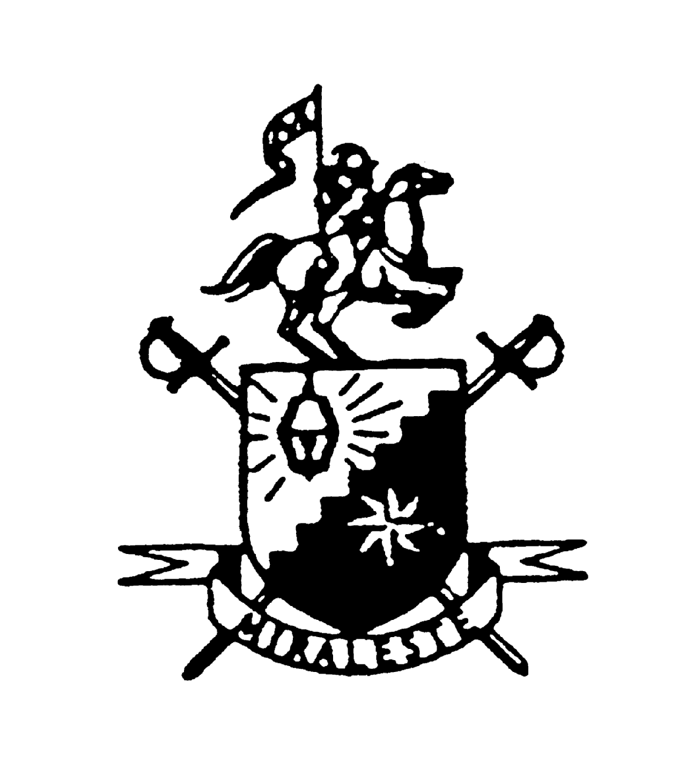
Bio-Book

Miraleste High School
Class of 1984
20-Year Reunion

Name
(first) (maiden) (last)

Address

Phone Number
E-mail Address
Occupation
Marital Status
Kids (names, ages)

What have you been doing since 1984? (education, locations, occupations, affiliations…)

Tell us something unusual that has occurred in your life in the past 20 years:

What comes to your mind when someone says the words “high school”?

When we graduated, I never would have believed that in 20 years I…

What would you like to accomplish in the next 20 years?

Any parting words…

